**Coding Challenge**

**CI/CD Pipeline Implementation in Azure DevOps**

This project showcases the implementation of a CI/CD pipeline in **Azure DevOps**, with integration to **Azure Data Factory (ADF)** and **Azure Databricks**. The primary objective is to automate code integration, testing, and deployment processes to achieve greater consistency, reliability, and quicker delivery cycles.

**CI/CD (Continuous Integration / Continuous Deployment)** is a core DevOps methodology that streamlines code integration, automated testing, and deployment.

As part of this project, we:

* Built an Azure DevOps pipeline to execute Python scripts.
* Connected the workflow with Azure Data Factory for orchestration.
* Leveraged Azure Databricks to perform transformations and advanced analytics.
* Set up a self-hosted agent to handle pipeline execution.

**Project Setup**

**Azure DevOps Setup**

1. Created a new **Azure DevOps Organization** and set up a Project.

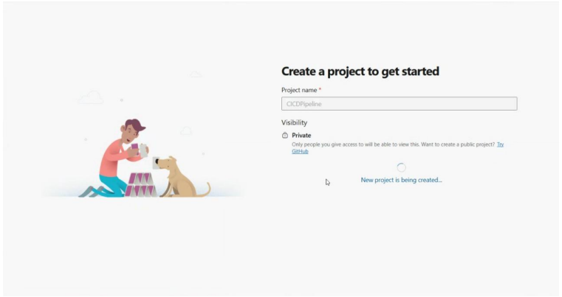

1. Initialized a repository with the following files:
   * README.md containing a project overview.

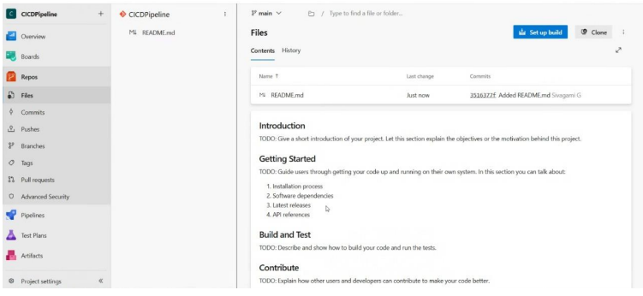

* + A sample Python script hello.py for testing.

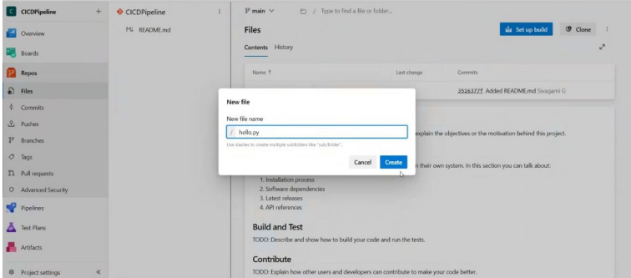

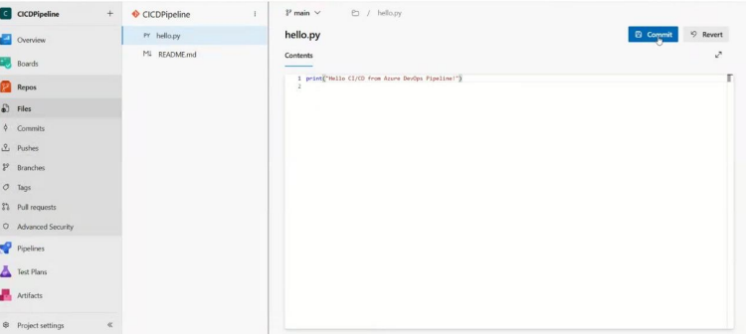

**Pipeline Setup**

**Creating the Pipeline in Azure DevOps**

1. Navigated to **Pipelines → New Pipeline**.

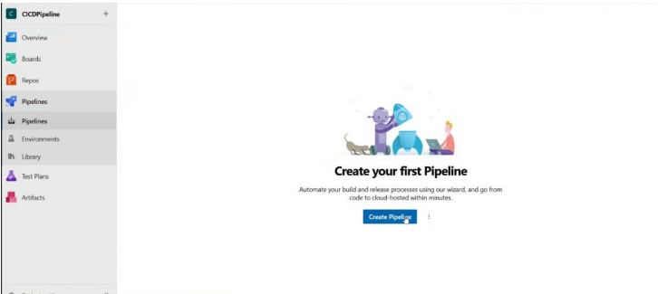

1. Selected **Azure Repos Git** as the code source.
2. Started with the **Starter pipeline** template and customized the YAML file.

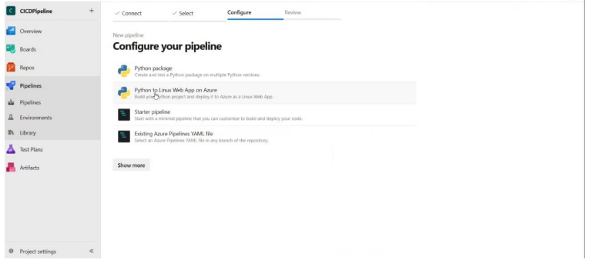

**YAML Configuration for Python Script Execution**

* Defined pipeline tasks in azure-pipelines.yml to install Python, run the script, and publish outputs.

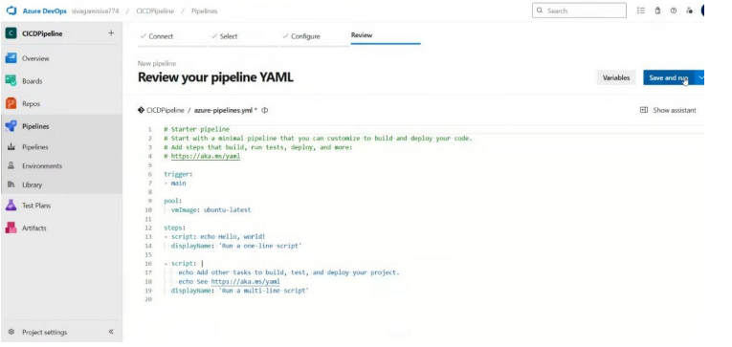

**Self-Hosted Agent**

**Setting Up the Agent**

1. Created a new **Agent Pool** in Azure DevOps.

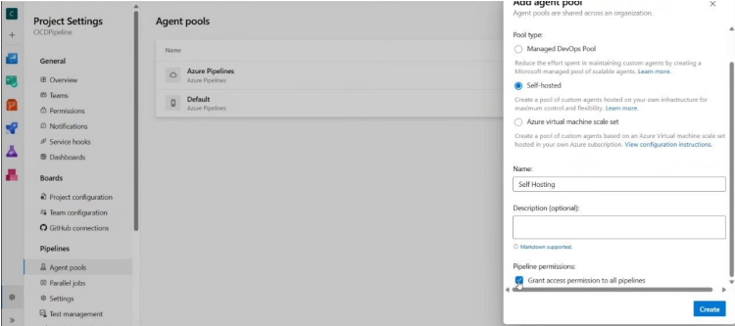

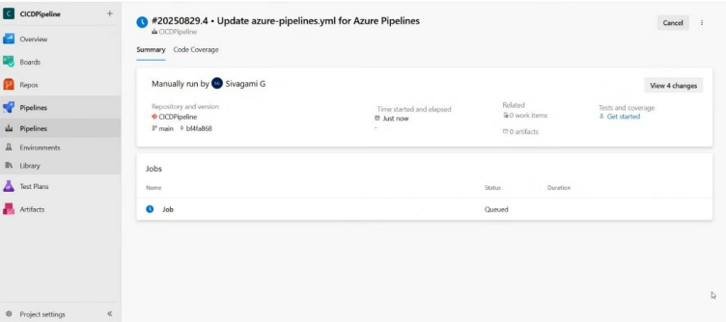

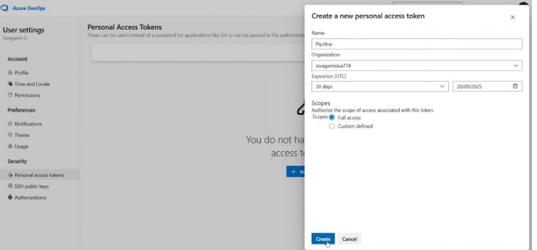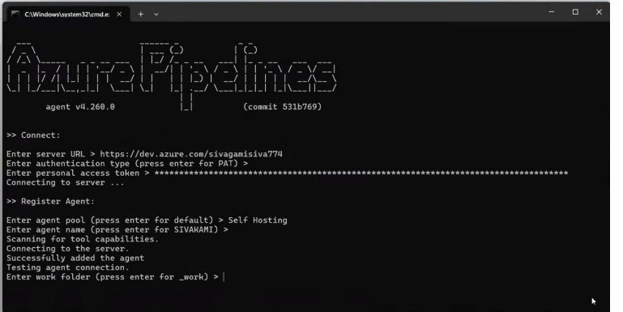

1. Downloaded and configured a **Self-Hosted Agent** on a local machine/VM.
   * Registered the agent with the DevOps project.
   * Verified that the agent was online and available.

**Linking the Pipeline to the Self-Hosted Agent**

* Updated azure-pipelines.yml to reference the custom agent pool.
* Ensured the self-hosted agent had Python installed and necessary permissions.

**Pipeline Execution**

1. Committed changes to the **main** branch.
2. The pipeline was triggered automatically (**Continuous Integration**).
3. The **Self-Hosted Agent** executed the job.
4. The Python script ran successfully, confirming the pipeline setup.

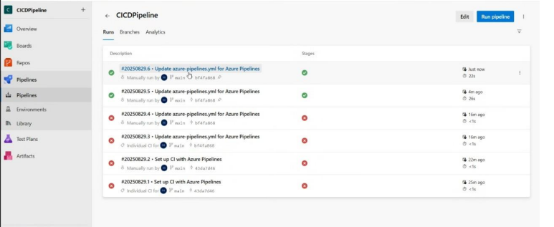

**Conclusion**

The project successfully demonstrated the creation and execution of a CI/CD pipeline in **Azure DevOps** using a self-hosted agent. By integrating automated code execution, testing, and artifact publishing, the pipeline ensures reliability, repeatability, and faster delivery.